Office of Mayor Carolyn G. Goodman

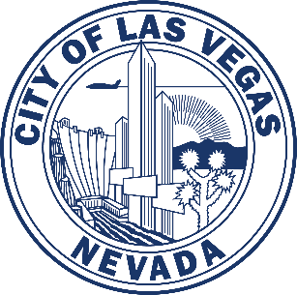

495 South Main Street, 7th Floor | Las Vegas, Nevada 89101
Phone: (702) 229-6241 | Fax: (702) 385-7960 | www.lasvegasnevada.gov

Welcome Letter Request Form
Please fill in the appropriate information. Once completed, please email this form to: mayorrequests@lasvegasnevada.gov. You may also send it by fax or mail (contact information above). Requests must be made two (2) weeks in advance.
Handwritten requests are strongly discouraged. All requests will be e-mailed as a PDF.
- Today’s date:
- Due date:
- Contact information of person making the request:
Name:
Organization:
Mailing address:
City, State, ZIP:
Cell and/or best daytime phone:
Email address:
- Name of the group/event:
- Date of event:
- Location of event:
- Is the group local or from out of town?
- Please provide a short description of the group and a website if available:

