Sample Application – Windows on First 2026
Cover Page
Artist Name: Jane Doe
Email: janedoe@example.com
Phone: (123) 456-7890
Project Title: "Light Echoes"

Project Proposal
Concept Summary:
“Light Echoes” is a site-specific installation designed to activate the First Street windows through layered, semi-translucent panels that shift in color depending on time of day and viewer position. The work captures themes of reflection, movement, and the sensory experience of downtown Las Vegas.
Materials:
Acrylic panels, dichroic film, LED backlighting (low-voltage).
Dimensions & Installation:
Each panel is custom cut to fit within the 14 ft x 13 ft 6 in window bays. Panels will be suspended with an aluminum track secured to the window frame/ceiling area without drilling into the glass. Installation will be completed with the assistance of an experienced fabricator.
Maintenance:
Minimal maintenance required. Artist will perform monthly check-ins for shifting panels.

Concept Rendering:
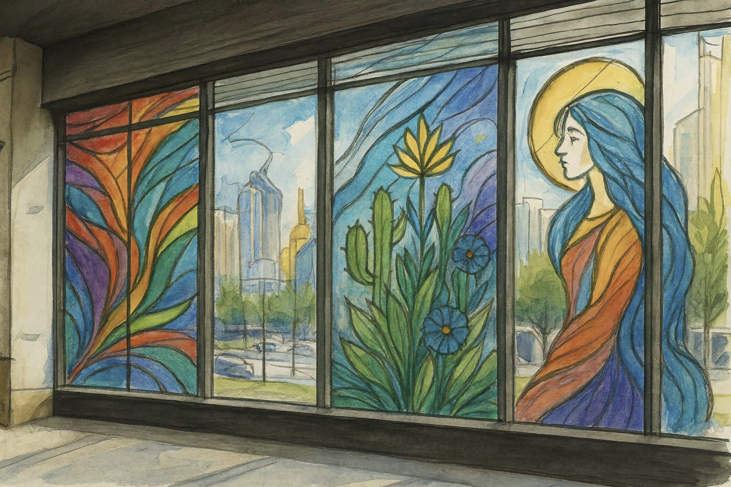
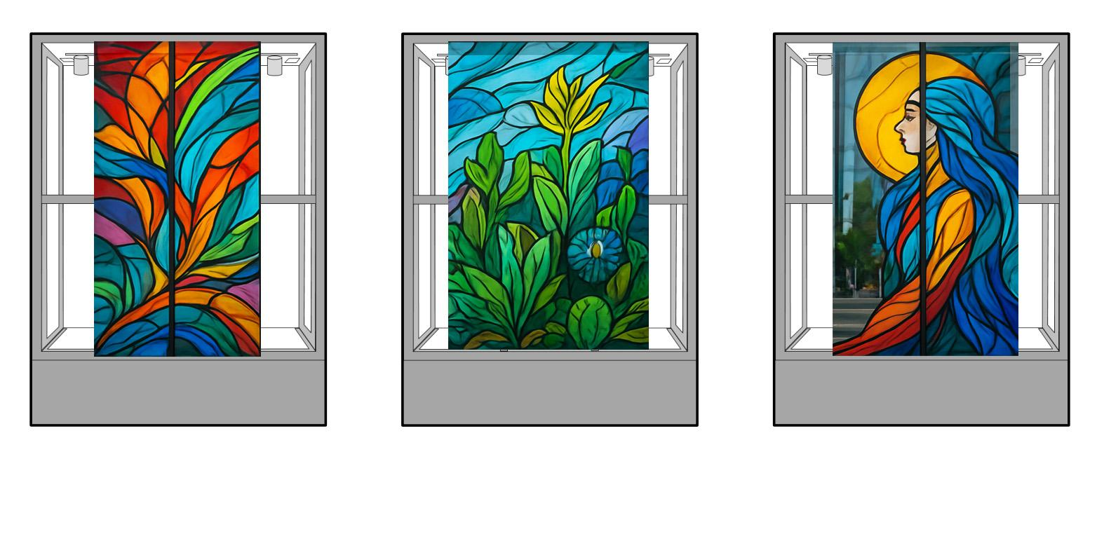

Resume/CV Example:
Jane Doe
Public Art • Installation • Mixed Media
Las Vegas, Nevada
janedoe@example.com | (123) 456-7890 | www.janedoeart.com

Education
2022 – MFA, Studio Art, University of Nevada, Las Vegas (UNLV)
2018 – BFA, Painting & Drawing, University of Nevada, Reno

Selected Public Art Projects
2024 – Color Drift, Reno City Plaza, Reno, NV. Acrylic panel permanent installation, 10 ft × 20 ft. Large-scale outdoor work exploring movement, landscape, and color through
layered translucent panels.
2023 – Urban Oasis, Temporary Public Art, Las Vegas, NV. Mixed media illuminated walkway installation transforming pedestrian corridors with botanical color fields.
2022 – Desert Light, UNLV Grant Hall Gallery – Public Installation Prototype
Glass-inspired painted panels exploring desert flora, spiritual light, and reflection. Developed as a prototype for future architectural integration.

Selected Exhibition History
2023 – Fragments (Solo Exhibition), Marjorie Barrick Museum Satellite Space, Las Vegas, NV
2023 – Lightwave, Contemporary Arts Center, Las Vegas, NV. LED installation investigating motion and perceptual blur.
2022 – MFA Thesis Exhibition, Donna Beam Fine Art Gallery, Las Vegas, NV
2021 – Emerging West, Nevada Arts Council, Traveling Exhibition

Grants, Commissions & Awards
2024 – City of Reno Public Art Commission – Color Drift
2023 – UNLV Graduate Research & Creative Activity Grant
2022 – UNLV College of Fine Arts Dean’s Award for Creative Achievement
2021 – Nevada Arts Council Emerging Artist Award (Finalist)

Public Collections
• City of Reno Public Art Collection
• UNLV College of Fine Arts Permanent Collection

References
Name, Job Title, Phone Number and Email
Past Work Images:

1. “Color Drift,” 2024 – Acrylic panels, 10 ft x 20 ft — Installed at Reno City Plaza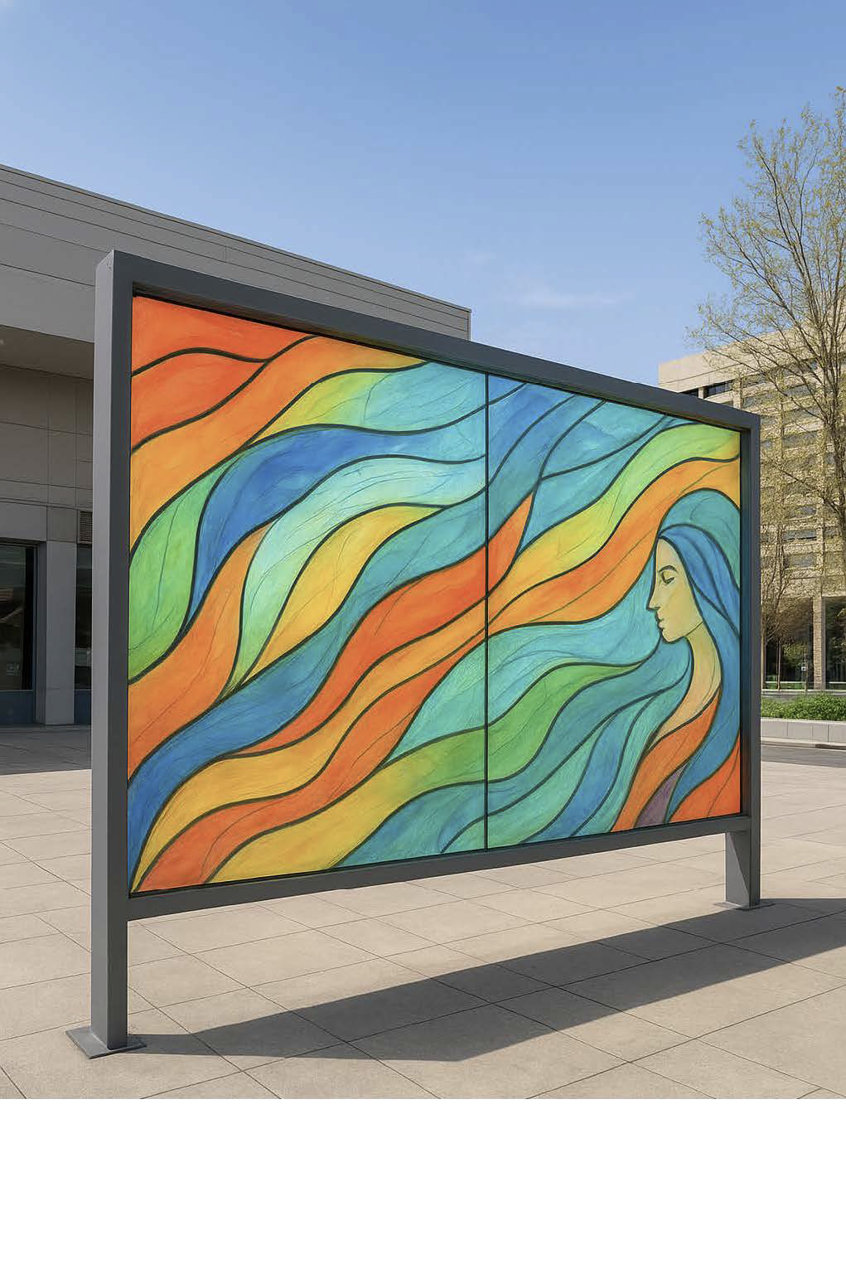

2. “Glass Memory,” 2023 – Mixed media sculpture — Exhibited at Contemporary Arts Center Las Vegas.
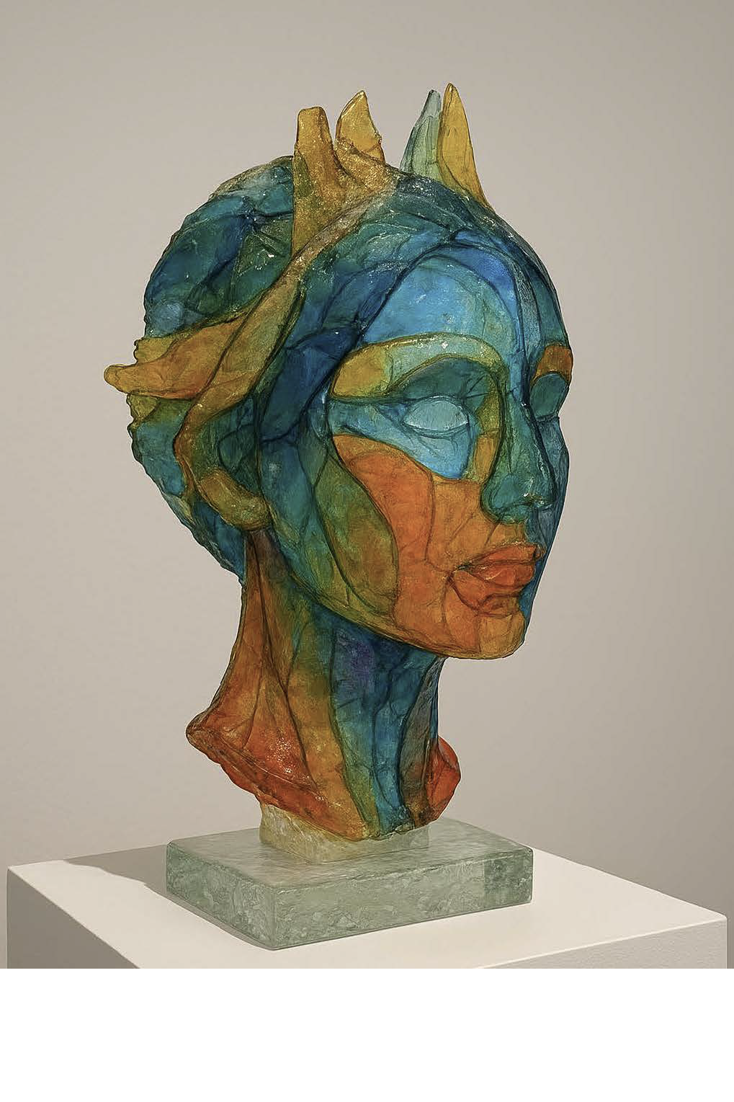

3. “Desert Light,” 2022 – Public installation prototype — UNLV Grant Hall Gallery.
