Office of Mayor Carolyn G. Goodman

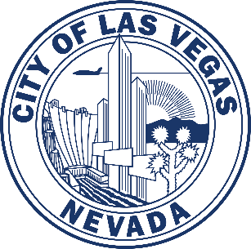

495 S. Main St, 7th Floor | Las Vegas, Nevada 89101
Phone: (702) 229-6241 | Fax: (702) 385-7960 | www.lasvegasnevada.gov

Proclamation Request Form

Note: Consideration is given to people, organizations, and/or events located within the City of Las Vegas
Please fill in the appropriate information. Once completed, please email this form to mayorrequests@lasvegasnevada.gov. You may also send it by fax or mail (contact information above). Requests must be made at least two (2) weeks in advance. Handwritten requests are strongly discouraged.
Best efforts are made to accommodate each request. However, requests for a date already requested or multiple requests from the same group within a year may be denied.

- Today’s date:
- Due date:
- Pick up at City Hall: ____ or Email to:
(Please note, we do not mail proclamations.)
- Contact information of person making the request:
Name:
Organization:
Cell and/or best daytime phone:
Email address:
- Specific title of what will be proclaimed (full name of person, event or organization to be celebrated):
- Date being proclaimed:
- Please provide at least 2-3 sentences about the person being recognized (i.e., reason for recognition) or 4-5 “Whereas” statements:

